**ACCOUNTING QUIZ 2**

**Dr. Sarfaraz Bhutto**

**B paper**

1. MAKE A TRIAL BALANCE FOR THE BELOW BALANCES.

Service Revenue =7500

Cash =5700

Accounts Receivable =6000

Supplies =1900

Prepaid Insurance=3600

Office Equipment=10200

Accounts Payable=4500

Unearned Service Revenue=2000

K. Ham, Capital =17700

Salaries Expense =3400

Rent Expense=900

B.

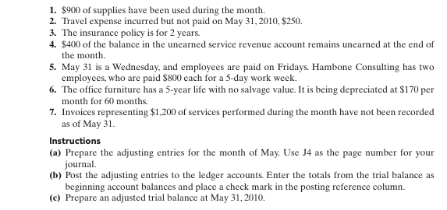

**SOLUTION**

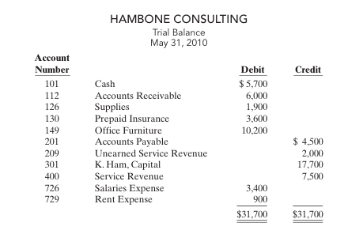

**ADJUSTING ENTRIES**

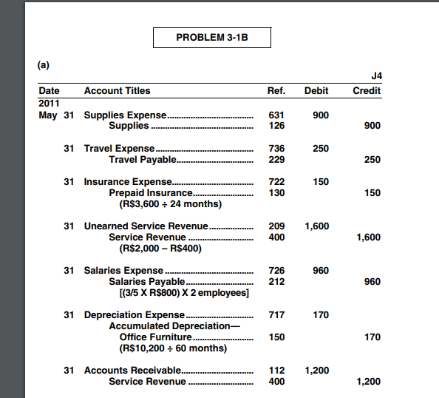

**LEDGERS**

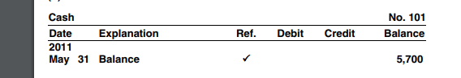

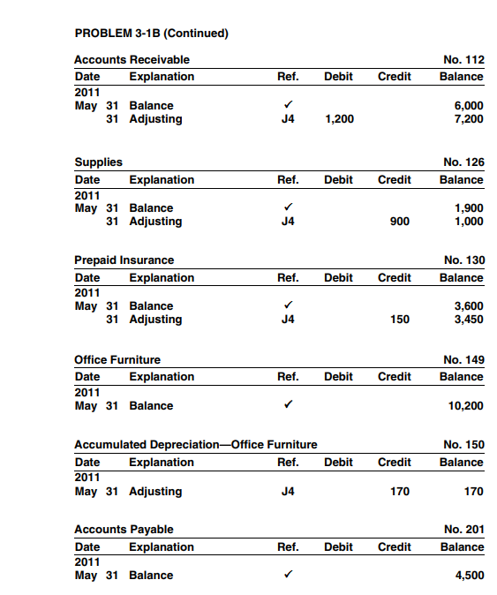

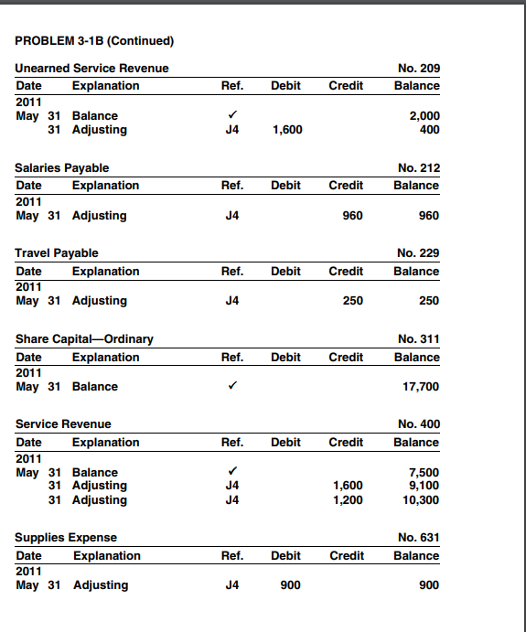

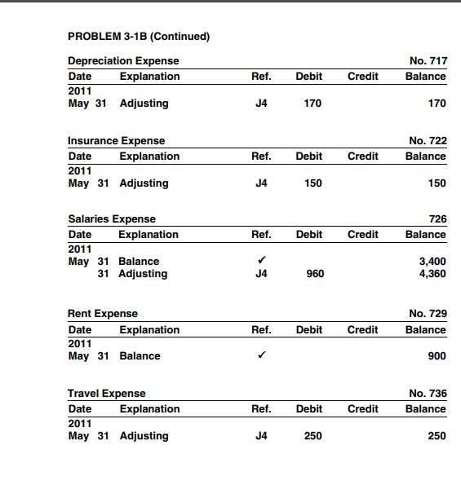

**ADJUSTED TRIAL BALANCE**

